**TEACHNOOK PROJECT**

**MAJOR PROJECT ON**

**(DIGITAL MARKETING)**

**BY**

**PALLEM Bharath Kumar**

**DIGITAL MARKETING :**

**Digital marketing** is the component of [marketing](https://en.wikipedia.org/wiki/Marketing) that uses the [Internet](https://en.wikipedia.org/wiki/Internet) and [online](https://en.wikipedia.org/wiki/Online)-based digital technologies such as [desktop computers](https://en.wikipedia.org/wiki/Desktop_computer), [mobile phones](https://en.wikipedia.org/wiki/Mobile_phone) and other [digital media](https://en.wikipedia.org/wiki/Digital_media) and platforms to promote products and services. Its development during the 1990s and 2000s revolutionized the way brands and businesses employ technology for [marketing](https://en.wikipedia.org/wiki/Marketing). As digital platforms became increasingly integrated into marketing plans and everyday life, and as people increasingly used digital devices instead of visiting physical shops, digital marketing campaigns have become prevalent, employing combinations of [search engine optimization](https://en.wikipedia.org/wiki/Search_engine_optimization) (SEO), [search engine marketing](https://en.wikipedia.org/wiki/Search_engine_marketing) (SEM), [content marketing](https://en.wikipedia.org/wiki/Content_marketing), [influencer marketing](https://en.wikipedia.org/wiki/Influencer_marketing), content automation, campaign marketing, [data](https://en.wikipedia.org/wiki/Data)-driven marketing, [e-commerce](https://en.wikipedia.org/wiki/E-commerce) marketing, [social media marketing](https://en.wikipedia.org/wiki/Social_media_marketing), [social media optimization](https://en.wikipedia.org/wiki/Social_media_optimization), [e-mail direct marketing](https://en.wikipedia.org/wiki/Email_marketing), [display advertising](https://en.wikipedia.org/wiki/Display_advertising), [e-books](https://en.wikipedia.org/wiki/E-book), and [optical disks](https://en.wikipedia.org/wiki/Optical_disc) and games have become commonplace. Digital marketing extends to non-Internet channels that provide digital media, such as [television](https://en.wikipedia.org/wiki/Television), mobile phones ([SMS](https://en.wikipedia.org/wiki/SMS) and [MMS](https://en.wikipedia.org/wiki/Multimedia_Messaging_Service)), callbacks, and on-hold mobile ring tones. This extension to non-Internet channels differentiates digital marketing from [online marketing](https://en.wikipedia.org/wiki/Online_marketing).

**HTML CODE:**

<!DOCTYPE html>

<html lang="en">

<head>

    <meta charset="UTF-8">

    <meta name="viewport" content="width=device-width, initial-scale=1.0">

    <meta name="description" content="Your website description for SEO">

    <title>Your Website Title</title>

    <link rel="stylesheet" href="styles.css">

    <link rel="preconnect" href="https://fonts.googleapis.com">

<link rel="preconnect" href="https://fonts.gstatic.com" crossorigin>

<link href="https://fonts.googleapis.com/css2?family=Dela+Gothic+One&display=swap" rel="stylesheet">

<link rel="stylesheet" href="https://cdnjs.cloudflare.com/ajax/libs/font-awesome/6.4.2/css/all.min.css" integrity="sha512-z3gLpd7yknf1YoNbCzqRKc4qyor8gaKU1qmn+CShxbuBusANI9QpRohGBreCFkKxLhei6S9CQXFEbbKuqLg0DA==" crossorigin="anonymous" referrerpolicy="no-referrer" />

</head>

<body>

    <header>

        <div>

        <h1 id="main-heading"> <span id="span-tag"> Company</h1>

        </div>

        <div class="circle"></div>

    <main>

        <section id="customer-conversion">

            <h2><a href="home-page.html"> Home </a></h2>

        </section>

        <section id="seo-optimization">

            <h2><a href="Services-page.html"> Services </a></h2>

        </section>

        <section id="form-filling">

            <h2><a href="about-us.html"> About Us </a></h2>

        </section>

        <section id="interactive-maps">

            <h2><a href="portfolio.html"> Portfolio </a></h2>

        </section>

        <section id="interactive-maps">

            <h2><a href="contact.html"> Contact Us </a></h2>

        </section>

     </main>

    </header>

    <div class="sub-body">

        <img src="https://img.freepik.com/free-vector/smm-social-media-network-influencer-marketing_335657-2466.jpg?w=1060&t=st=1696583261~exp=1696583861~hmac=ef396b42071d6a1198561a27ac50b63a49d116035bebae7e35b52abd0a373e8f" alt="img">

       <h3>

            Digital<br><span>Marketing</span>

        </h3>

        <p class="para">

            In Today's digital landscape, businesses that harness the power of digital marketing can connect with their audience, drive brand growth, and stay competitive in a rapidly changing marketplace.

        </p>

        <button><a href="#"> Learn More </a></button>

    </div>

    <div id="icons">

        <ul>

            <li><a href="#"><i class="fa-brands fa-facebook-f"></i></a></li>

            <li><a href="#"><i class="fa-brands fa-instagram"></i></a></li>

            <li><a href="#"><i class="fa-brands fa-twitter"></i></a></li>

        </ul>

    </div>

    <footer>

        <p>&copy; 2023 Digital Marketing. All rights reserved.</p>

    </footer>

    <div class="circle"></div>

</body>

</html>

**CSS CODE:**

body, h1, h2, p {

    margin: 0;

    padding: 0;

}

body {

    font-family: 'Arial', sans-serif;

    line-height: 1.6;

}

header {

    color: #fff;

    text-align: center;

    padding: 1em;

    display: flex;

}

main {

    max-width: 900px;

    margin: 0 auto;

    padding: 20px;

    display: flex;

    justify-content: end;

    margin-left: 27%;

}

section {

    margin-bottom: 20px;

    margin-left: 30px;

}

form {

    display: grid;

    grid-template-columns: 1fr 1fr;

    gap: 10px;

}

footer {

    background-color: #333;

    color: #fff;

    text-align: center;

    padding: 1em;

    /* position: fixed; */

    bottom: 0;

    width: 100%;

}

h2 a {

    text-decoration: none;

    color: rgb(40, 40, 185);

    transition: 0.5s ease;

    font-family: 'Courgette', cursive;

}

h2 a:hover {

    color: rgb(252, 108, 56);

    letter-spacing: 3px;

}

#main-heading {

    width: 400px;

    font-size: 46px;

    margin: 10px;

    margin-left: -90px;

}

img {

    float: right;

    width: 800px;

    height: 500px;

}

.sub-body h3 {

    font-size: 66px;

    color: rgb(40, 40, 185);

    margin-left: 80px;

    /* font-family: 'Dela Gothic One', cursive; */

    font-family: 'Dela Gothic One', cursive;

}

.para {

    font-size: 22px;

    margin-left: 35px;

    position: relative;

    content: "";

    top: -40px;

    text-indent: 60px;

    max-width: 40%;

    font-family: 'Caveat', cursive;

}

#span-tag {

    color: rgb(40, 40, 185);

    font-size: 32px;

    font-weight: 900;

    position: absolute;

    margin-left: -110px;

    font-family: 'Russo One', sans-serif;

}

span {

    font-size: 68px;

    color: rgb(252, 108, 56);

    font-family: 'Permanent Marker', cursive;

}

button {

    width: 110px;

    height: 25px;

    background-color: rgb(252, 108, 56);

    border-radius: 10px;

    border-style: none;

    margin: 5px;

    margin-left: 90px;

    transition: 0.5s ease;

}

button a {

    color: #fff;

    font-size: 14px;

    text-decoration: none;

}

button:hover {

    transform: scale(0.9);

}

#icons ul li {

    list-style: none;

    margin-left: 15px;

    font-size: 22px;

    transition: 0.3s ease;

}

#icons ul li:hover {

    transform: translateY(-10%);

}

#icons ul {

    display: flex;

    flex-direction: row;

    margin-left: 40px;

}

.circle {

    position: absolute;

    top: 0;

    left: 0;

    width: 100%;

    height: 100%;

    background-color: rgb(113, 208, 245);

    clip-path: circle(280px at left -120px);

    z-index: -1;

    opacity: 0.3;

}

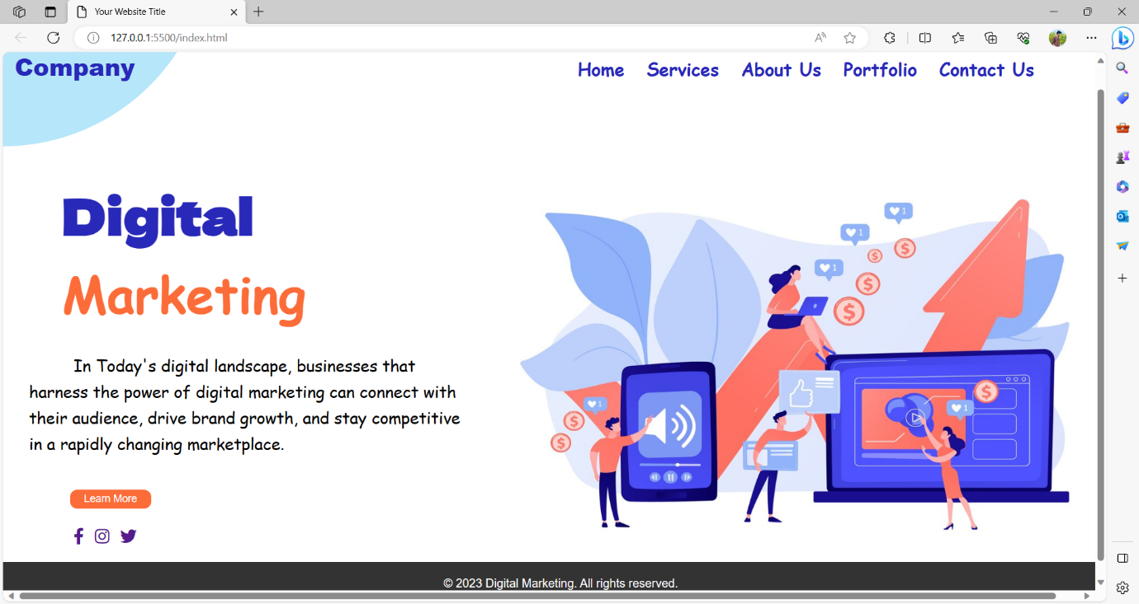

**HOME PAGE:**

<!DOCTYPE html>

<html lang="en">

<head>

    <meta charset="UTF-8">

    <meta name="viewport" content="width=device-width, initial-scale=1.0">

    <title>Your Company - Home</title>

    <link rel="preconnect" href="https://fonts.googleapis.com">

    <link rel="preconnect" href="https://fonts.gstatic.com" crossorigin>

    <link href="https://fonts.googleapis.com/css2?family=Dela+Gothic+One&display=swap" rel="stylesheet">

    <style>

        body {

            font-family: 'Arial', sans-serif;

            margin: 0;

            padding: 0;

            box-sizing: border-box;

            background-color: #f8f8f8;

            color: #333;

        }

        header {

            /* background-color: rgb(40, 40, 185); */

            color: rgb(40, 40, 185);

            padding: 20px;

            text-align: left;

        }

        h1, h2 {

            color: #2c3e50;

        }

        section {

            margin: 20px;

            margin-top: 50px;

            padding: 30px;

            border-radius: 8px;

        }

        .cta {

            display: flex;

            width: 90%;

            flex-direction: column;

            justify-content: space-around;

            align-items: center;

            flex-wrap: wrap;

        }

        .cta-item {

            flex: 1;

            text-align: center;

            margin: 10px;

            padding: 20px;

            background-color: #3498db;

            color: #ecf0f1;

            border-radius: 8px;

            cursor: pointer;

            transition: background-color 0.3s ease-in-out;

        }

        .cta-item:hover {

            background-color: #2980b9;

        }

        .featured-content {

            display: flex;

            justify-content: space-around;

            align-items: center;

            flex-wrap: wrap;

        }

        .featured-item {

            flex: 1;

            text-align: center;

            margin: 10px;

            padding: 30px;

            background-color: #ecf0f1;

            border-radius: 8px;

            box-shadow: 0 0 10px rgba(44, 62, 80, 0.1);

        }

        footer {

            background-color: #2c3e50;

            color: #ecf0f1;

            padding: 15px;

            text-align: center;

            bottom: 0;

            width: 100%;

        }

        a {

            text-decoration: none;

            color: #fff;

        }

        #b {

            color: rgb(252, 108, 56);

            font-size: 38px;

            font-family: 'Dela Gothic One', cursive;

        }

        .circle {

            position: absolute;

            top: 0;

            left: 0;

            height: 100%;

            width: 100%;

            background-color: rgb(113, 208, 245);

            z-index: -1;

            clip-path: circle(280px at left -120px);

            opacity: 0.5;

        }

        .main {

            display: flex;

        }

        #img {

            margin-left: 50px;

        }

    </style>

</head>

<body>

<header>

    <h1 id="b"> Home </h1>

</header>

<div class="circle"></div>

<div class="main">

<section id="hero">

    <h2>Welcome to Our Company</h2>

    <p>Transform your business with innovative digital marketing solutions.</p>

      <div class="cta">

        <div class="cta-item" onclick="redirectToServices()"><a href="Services-page.html">

            <h3>Our Services</h3>

            <p>Explore our comprehensive digital marketing offerings.</p></a>

        </div>

        <div class="cta-item" onclick="redirectToContact()"><a href="contact.html">

            <h3>Contact Us</h3>

            <p>Get in touch to discuss your business needs.</p></a>

        </div>

    </div>

</section>

<div>

    <img id="img" src="https://o.remove.bg/downloads/b914c969-1aab-454a-bfcd-a78a2d2f8532/tiny-business-people-innovative-smart-home-automation-system-smart-home-2-0-generation-iot-home-with-cognitive-intelligence-concept_335657-654-removebg-preview.png" width="700px">

</div>

</div>

<section id="features">

    <h2>Featured Content</h2>

    <div class="featured-content">

        <div class="featured-item">

            <h3>SEO Optimization</h3>

            <p>Boost your online presence with our expert SEO techniques.</p>

        </div>

        <div class="featured-item">

            <h3>PPC Campaigns</h3>

            <p>Drive conversions and maximize ROI with targeted PPC advertising.</p>

        </div>

    </div>

</section>

<footer>

    <p>&copy; 2023 Digital Marketing. All rights reserved.</p>

</footer>

<script>

    function redirectToServices() {

        window.location.href = 'services.html';

    }

    function redirectToContact() {

        window.location.href = 'contact.html';

    }

</script>

</body>

</html>

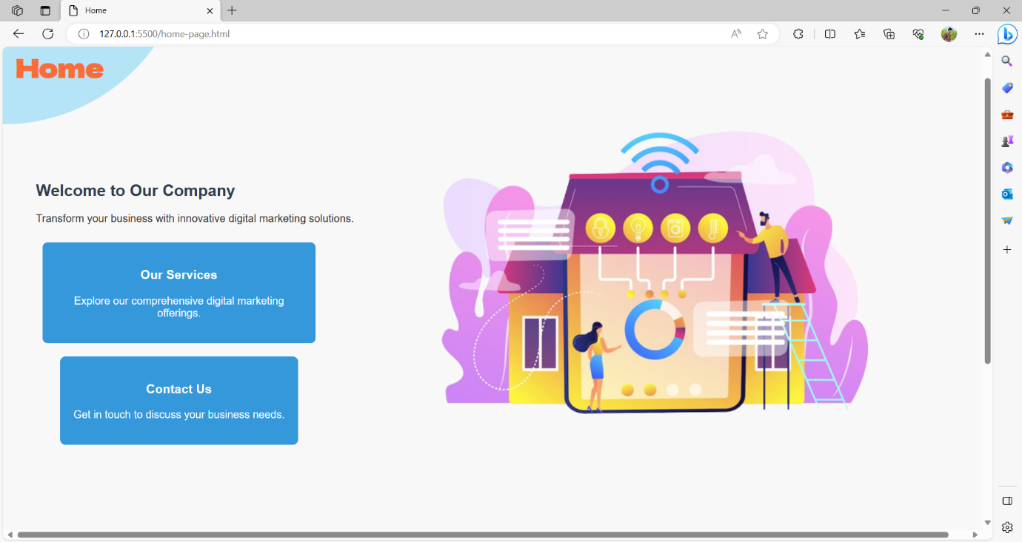

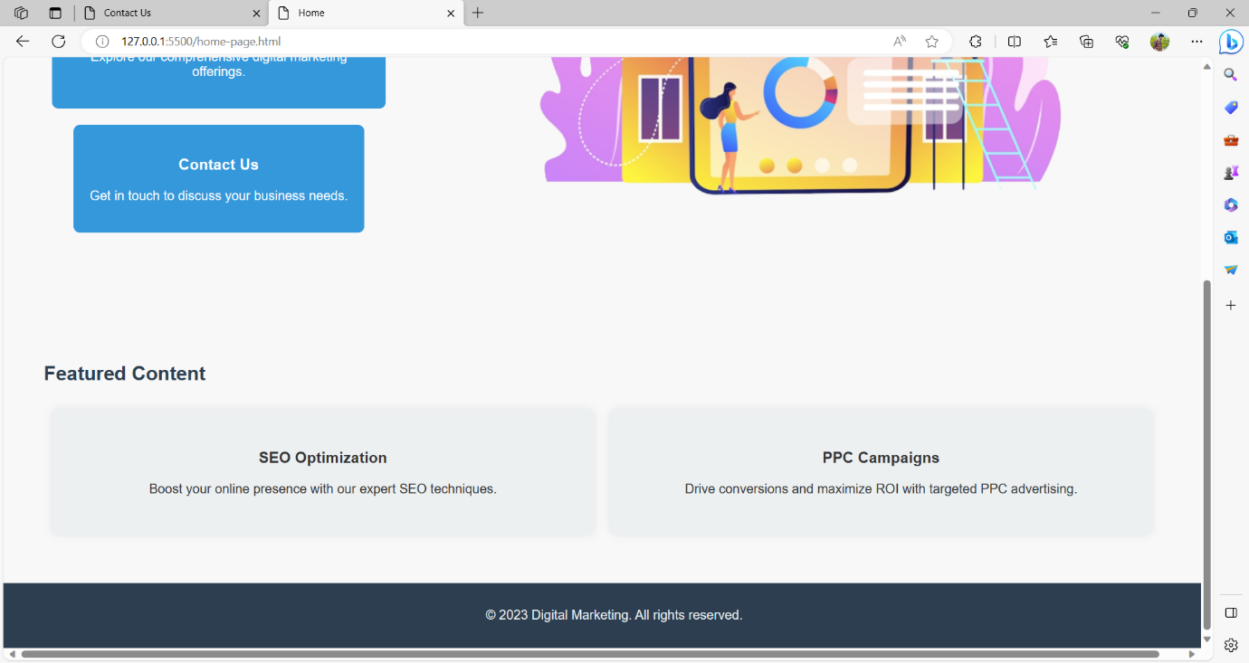

**SERVICES PAGE:**

<!DOCTYPE html>

<html lang="en">

<head>

    <meta charset="UTF-8">

    <meta name="viewport" content="width=device-width, initial-scale=1.0">

    <title>Our Digital Marketing Services</title>

    <link rel="preconnect" href="https://fonts.googleapis.com">

    <link rel="preconnect" href="https://fonts.gstatic.com" crossorigin>

    <link href="https://fonts.googleapis.com/css2?family=Dela+Gothic+One&display=swap" rel="stylesheet">

    <style>

        body {

            font-family: 'Roboto', sans-serif;

            margin: 0;

            padding: 0;

            box-sizing: border-box;

            background-color: #f5f5f5;

            color: #333;

        }

        header {

            color: #ecf0f1;

            padding: 20px;

            text-align: left;

        }

        h1, h2 {

            color: black;

        }

        section {

            margin: 20px;

            padding: 30px;

            /* background-color: #fff; */

            border-radius: 8px;

            /* box-shadow: 0 0 20px rgba(44, 62, 80, 0.1); */

            transition: transform 0.3s ease-in-out;

        }

        /* section:hover {

            transform: scale(1.02);

        } */

        button {

            padding: 15px;

            background-color: #3498db;

            color: #ecf0f1;

            border: none;

            border-radius: 4px;

            cursor: pointer;

            transition: background-color 0.3s ease-in-out;

        }

        button:hover {

            background-color: #2980b9;

        }

        form {

            margin-top: 20px;

            display: flex;

            flex-direction: column;

            align-items: center;

        }

        label {

            margin-bottom: 10px;

            color: #2c3e50;

        }

        input {

            padding: 10px;

            margin-bottom: 15px;

            width: 100%;

            box-sizing: border-box;

        }

        footer {

            background-color: #2c3e50;

            color: #ecf0f1;

            padding: 20px;

            text-align: center;

        }

        #heading {

            color: rgb(252, 108, 56);

            font-family: 'Dela Gothic One', cursive;

            font-size: 30px;

        }

        .circle {

         position: absolute;

         top: 0;

         left: 0;

         width: 100%;

         height: 100%;

         background-color: rgb(113, 208, 245);

         clip-path: circle(310px at left -80px);

         z-index: -1;

         opacity: 0.7;

    }

    #seoService img {

        float: right;

        position: absolute;

        content: "";

        right: -1px;

        top: 90px;

    }

    #seoService  {

        display: flex;

    }

    .seo {

        width: 50%;

        margin-top: 10%;

    }

    .circle2 {

         position: absolute;

         top: 0;

         left: 0;

         width: 100%;

         height: 100%;

         background-color: orangered;

         clip-path: circle(710px at right );

         /* -webkit-clip-path: polygon(100% 80%, 50% 37%, 44% 45%, 43% 52%, 46% 56%, 55% 59%, 100% 62%);

clip-path: polygon(100% 36%, 50% 37%, 44% 45%, 43% 52%, 46% 56%, 55% 59%, 100% 62%); */

         z-index: -1;

         opacity: 0.7;

    }

    </style>

</head>

<body>

<header>

    <h1 id="heading">Our Digital<br> Marketing <br>Services</h1>

</header>

<div class="circle"></div>

<div class="circle2"></div>

<section id="seoService">

    <div class="seo" align="center">

    <h2>SEO Optimization</h2>

    <p>Boost your online presence and improve search engine visibility with our expert SEO techniques.</p>

    <button onclick="contactButtonClick('SEO Optimization')">Contact Us</button>

    </div>

    <div>

        <img src="https://o.remove.bg/downloads/34441b17-b1e1-4cab-bef6-cd6e9270b93f/hand-drawn-illustration-people-with-smartphone-marketing_52683-66659-removebg-preview.png">

    </div>

</section>

<section id="contact">

    <h2>Contact Us</h2>

    <p>Ready to take your business to the next level? Reach out to discuss your digital marketing needs.</p>

    <form id="contactForm" onsubmit="return validateForm()">

        <label for="name">Name:</label>

        <input type="text" id="name" name="name" required>

        <label for="email">Email:</label>

        <input type="email" id="email" name="email" required>

        <button type="submit">Submit</button>

    </form>

</section>

<footer>

    <p>&copy; 2023 Digital Marketing. All rights reserved.</p>

</footer>

</body>

</html>

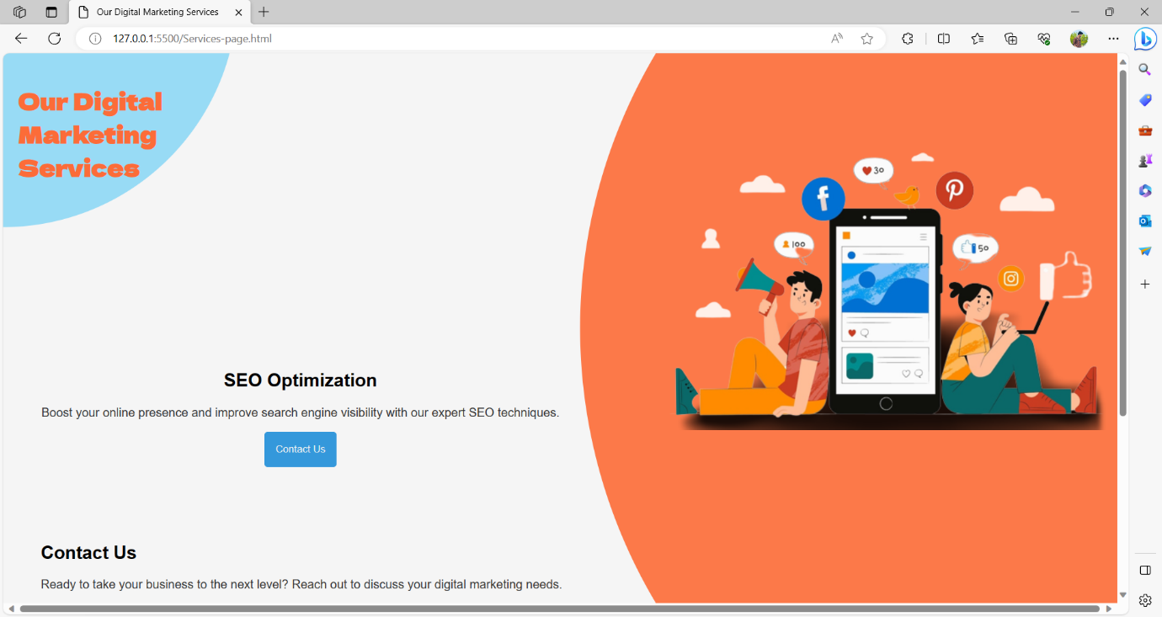

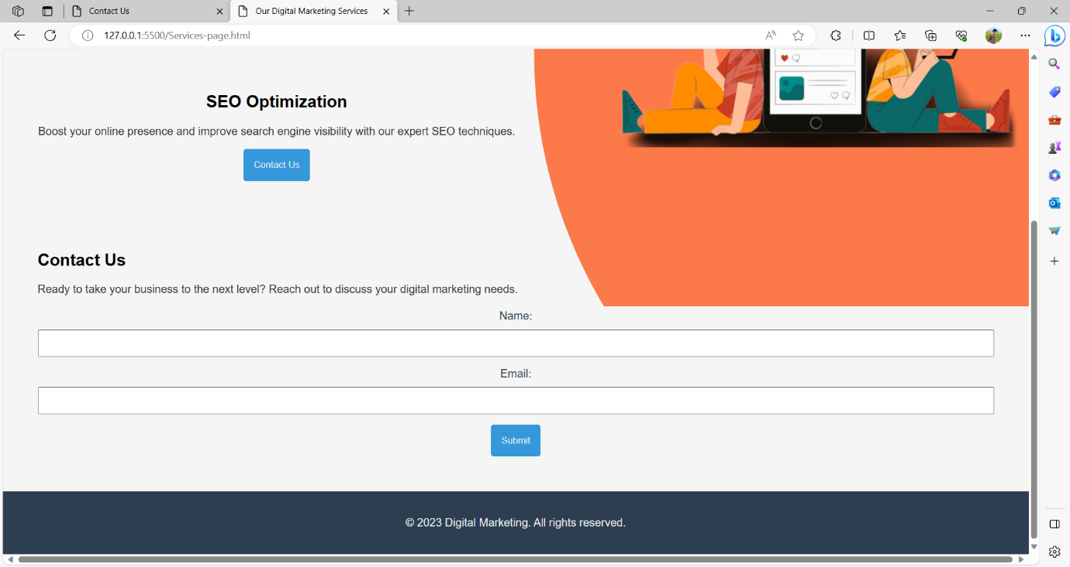

**ABOUT US PAGE:**

<!DOCTYPE html>

<html lang="en">

<head>

    <meta charset="UTF-8">

    <meta name="viewport" content="width=device-width, initial-scale=1.0">

    <title>About Us</title>

    <link rel="preconnect" href="https://fonts.googleapis.com">

    <link rel="preconnect" href="https://fonts.gstatic.com" crossorigin>

    <link href="https://fonts.googleapis.com/css2?family=Dela+Gothic+One&display=swap" rel="stylesheet">

    <style>

        body {

            font-family: 'Arial', sans-serif;

            margin: 0;

            padding: 0;

            box-sizing: border-box;

            background-color: #f8f8f8;

            color: #333;

        }

        header {

            color: #ecf0f1;

            padding: 20px;

            text-align: left;

        }

        h1, h2 {

            color: #2c3e50;

        }

        section {

            margin: 20px;

            margin-top: 10px;

            padding: 30px;

            background-color: #ecf0f1;

            border-radius: 8px;

            box-shadow: 0 0 20px rgba(44, 62, 80, 0.1);

        }

        form {

            margin-top: 20px;

            display: flex;

            flex-direction: column;

            align-items: center;

        }

        label {

            margin-bottom: 10px;

            color: #2c3e50;

        }

        input, textarea {

            padding: 10px;

            margin-bottom: 15px;

            width: 100%;

            box-sizing: border-box;

        }

        button {

            padding: 15px;

            background-color: #3498db;

            color: #ecf0f1;

            border: none;

            border-radius: 4px;

            cursor: pointer;

            transition: background-color 0.3s ease-in-out;

        }

        button:hover {

            background-color: #2980b9;

        }

        #a {

            color: rgb(252, 108, 56);

            font-family: 'Dela Gothic One', cursive;

        }

        footer {

            background-color: #2c3e50;

            color: #ecf0f1;

            padding: 20px;

            text-align: center;

        }

    .circle {

    position: absolute;

    top: 0;

    left: 0;

    width: 100%;

    height: 100%;

    background-color: rgb(113, 208, 245);

    clip-path: circle(280px at left -120px);

    z-index: -1;

    opacity: 0.7;

}

    .sub {

        display: flex;

    }

    #companyStory {

        width: 30%;

        justify-content: center;

    }

    #companyStory h2 {

        margin-top: 30%;

    }

    #expertise {

        align-items: center;

        justify-content: center;

    }

    #expertise h2 {

        margin-top: 32%;

    }

    </style>

</head>

<body>

<header>

    <h1 id="a">About<br> Us </h1>

    <div class="circle"></div>

</header>

<div class="sub">

    <img src="https://o.remove.bg/downloads/3ada1883-16c3-4c22-b69d-ad96dfbb7b6b/mobile-marketing-concept-illustration_114360-1497-removebg-preview.png">

    <section id="companyStory">

      <h2>Our Story</h2>

      <p>Welcome to Our Company, where innovation meets success. Since our inception, we have been dedicated to delivering cutting-edge solutions and achieving remarkable milestones in the digital landscape.</p>

    </section>

    <section id="expertise">

     <h2>Expertise and Successes</h2>

     <p>With a team of skilled professionals, we specialize in...</p>

    </section>

</div>

<section id="contact">

    <h2>Contact Us</h2>

    <p>Have questions or want to learn more? Get in touch with us using the form below:</p>

    <form id="inquiryForm" onsubmit="return validateForm()">

        <label for="name">Name:</label>

        <input type="text" id="name" name="name" required>

        <label for="email">Email:</label>

        <input type="email" id="email" name="email" required>

        <label for="message">Message:</label>

        <textarea id="message" name="message" rows="4" required></textarea>

        <button type="submit">Submit</button>

    </form>

</section>

<footer>

    <p>&copy; 2023 Digital Marketing. All rights reserved.</p>

</footer>

<script>

    function validateForm() {

        var name = document.getElementById('name').value;

        var email = document.getElementById('email').value;

        var message = document.getElementById('message').value;

        if (name === '' || email === '' || message === '') {

            alert('Name, email, and message are required fields.');

            return false;

        }

        alert('Form submitted successfully!');

        return true;

    }

</script>

</body>

</html>

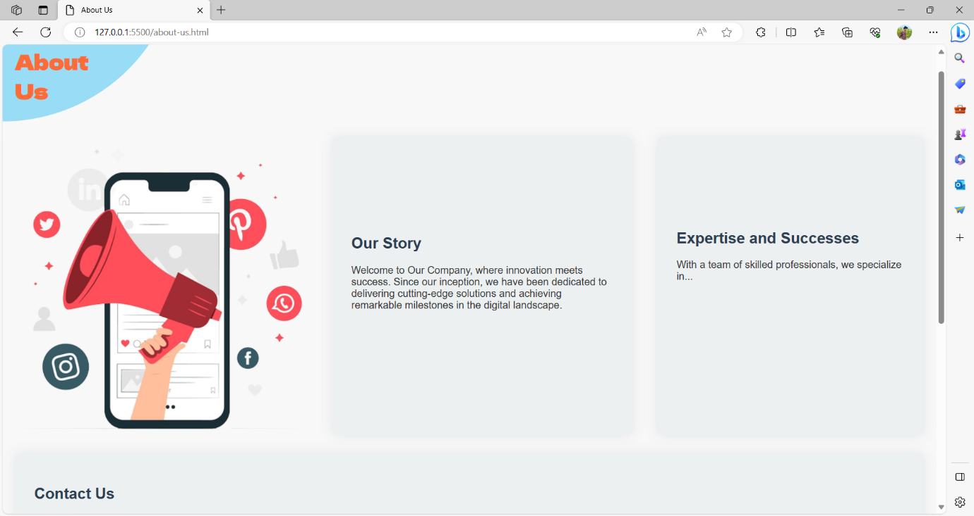

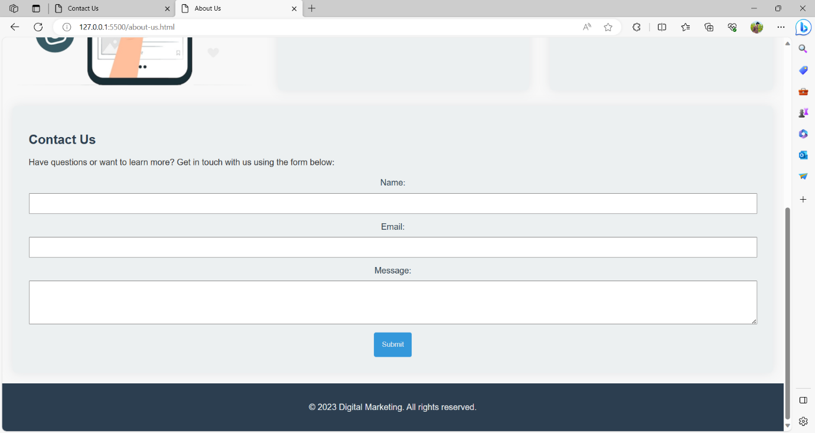

**PORTFOLIO PAGE:**

<!DOCTYPE html>

<html lang="en">

<head>

    <meta charset="UTF-8">

    <meta name="viewport" content="width=device-width, initial-scale=1.0">

    <title>Portfolio</title>

    <link rel="preconnect" href="https://fonts.googleapis.com">

    <link rel="preconnect" href="https://fonts.gstatic.com" crossorigin>

    <link href="https://fonts.googleapis.com/css2?family=Dela+Gothic+One&display=swap" rel="stylesheet">

    <style>

        body {

            font-family: 'Arial', sans-serif;

            margin: 0;

            padding: 0;

            box-sizing: border-box;

            background-color: #f8f8f8;

            color: #333;

        }

        header {

            color: #ecf0f1;

            padding: 20px;

            text-align: left;

        }

        h1, h2 {

            color: #2c3e50;

        }

        section {

            margin: 20px;

            margin-top: 45px;

            margin-left: 5%;

            padding: 30px;

            background-color: #ecf0f1;

            border-radius: 8px;

            box-shadow: 0 0 20px rgba(44, 62, 80, 0.1);

        }

        .analytics {

            display: flex;

            justify-content: space-between;

            align-items: center;

        }

        .analytics-item {

            flex: 1;

            text-align: center;

            padding: 20px;

            margin: 10px;

            background-color: #3498db;

            color: #ecf0f1;

            border-radius: 8px;

        }

        .portfolio-item {

            margin-bottom: 20px;

        }

        footer {

            background-color: #2c3e50;

            color: #ecf0f1;

            padding: 15px;

            text-align: center;

            bottom: 0;

            width: 100%;

        }

        #a {

            color: rgb(252, 108, 56);

            font-family: 'Dela Gothic One', cursive;

            text-indent: -8px;

        }

        .circle {

    position: absolute;

    top: 0;

    left: 0;

    width: 100%;

    height: 100%;

    background-color: rgb(113, 208, 245);

    clip-path: circle(280px at left -120px);

    z-index: -1;

    opacity: 0.7;

}

    .body {

        display: flex;

    }

    .body img {

       margin-left: 20%;

       width: 400px;

    }

    </style>

</head>

<body>

<header>

    <h1 id="a"> Portfolio </h1>

</header>

<div class="circle"></div>

<div class="body">

    <section id="portfolio">

       <h2>Our Successful Campaigns</h2>

       <div class="portfolio-item">

           <h3>Campaign Title 1</h3>

           <p>Description of the campaign...</p>

       </div>

    <div class="portfolio-item">

        <h3>Campaign Title 2</h3>

        <p>Description of the campaign...</p>

    </div>

    </section>

<img src="https://o.remove.bg/downloads/985ba3a4-f98c-4af7-92ce-92843aad154e/social-tree-concept-illustration_114360-4898-removebg-preview.png">

</div>

<section id="analytics">

    <h2>Real-time Analytics</h2>

    <div class="analytics">

        <div class="analytics-item">

            <h3>Impressions</h3>

            <p id="impressions">0</p>

        </div>

        <div class="analytics-item">

            <h3>Clicks</h3>

            <p id="clicks">0</p>

        </div>

        <div class="analytics-item">

            <h3>Conversions</h3>

            <p id="conversions">0</p>

        </div>

    </div>

    <script>

        function updateAnalytics() {

            setInterval(() => {

                document.getElementById('impressions').innerText = Math.floor(Math.random() * 1000);

                document.getElementById('clicks').innerText = Math.floor(Math.random() * 100);

                document.getElementById('conversions').innerText = Math.floor(Math.random() * 10);

            }, 5000);

        }

        updateAnalytics();

    </script>

</section>

<footer>

    <p>&copy; 2023 Digital Marketing. All rights reserved.</p>

</footer>

</body>

</html>

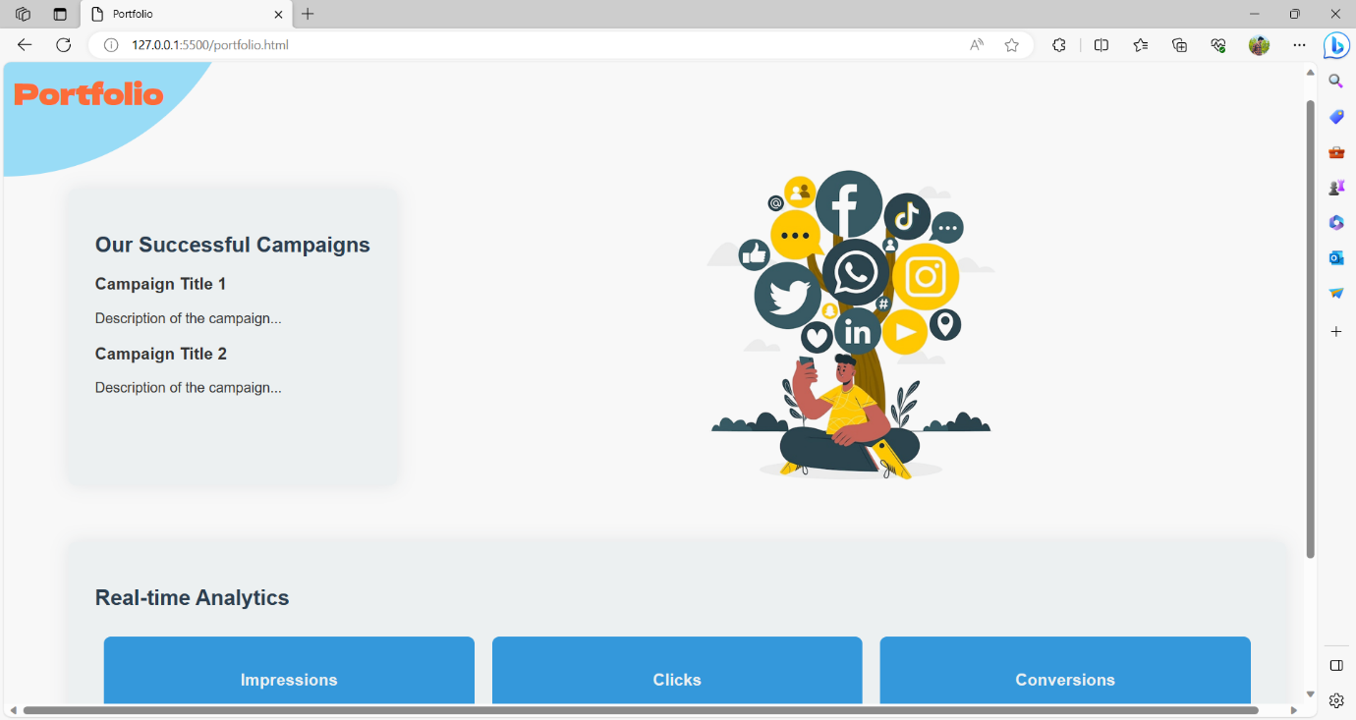

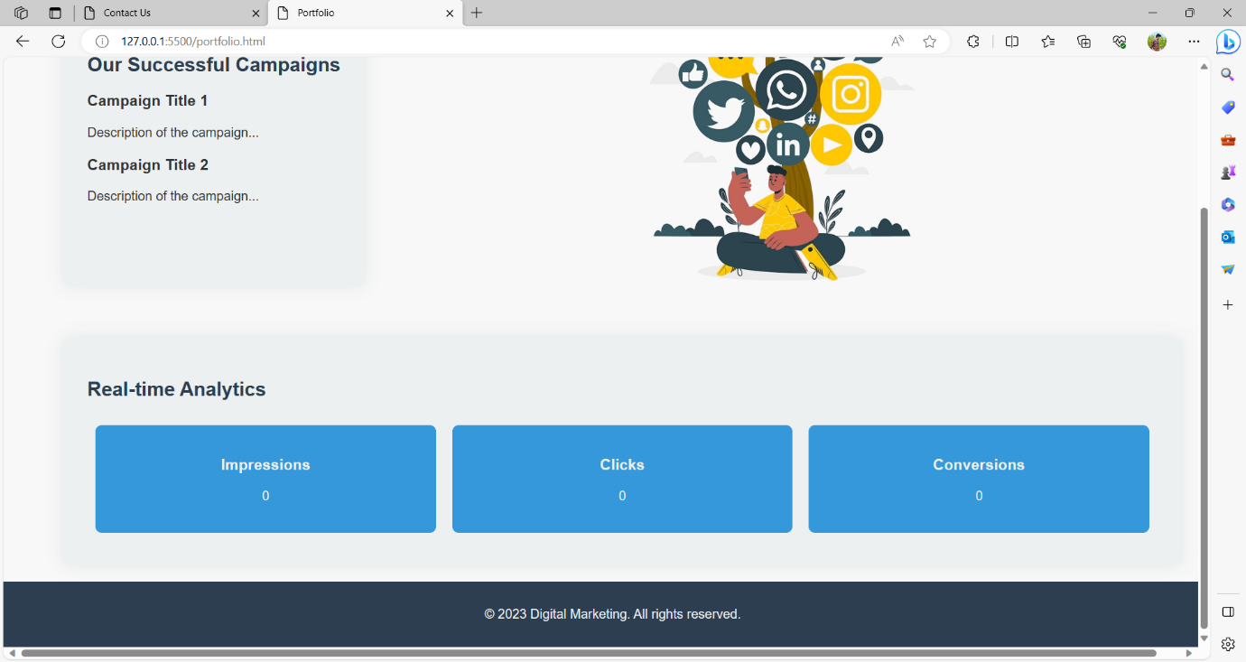

**CONTACT US PAGE:**

<!DOCTYPE html>

<html lang="en">

<head>

    <meta charset="UTF-8">

    <meta name="viewport" content="width=device-width, initial-scale=1.0">

    <title>Contact Us</title>

    <link rel="preconnect" href="https://fonts.googleapis.com">

    <link rel="preconnect" href="https://fonts.gstatic.com" crossorigin>

    <link href="https://fonts.googleapis.com/css2?family=Dela+Gothic+One&display=swap" rel="stylesheet">

    <style>

        body {

            font-family: 'Arial', sans-serif;

            margin: 0;

            padding: 0;

            box-sizing: border-box;

            background-color: #f8f8f8;

            color: #333;

        }

        header {

            color: #ecf0f1;

            padding: 20px;

            text-align: left;

        }

        h1, h2 {

            color: #2c3e50;

        }

        section {

            width: 55%;

            margin: 20px;

            margin-top: 40px;

            padding: 30px;

            background-color: #ecf0f1;

            border-radius: 8px;

            box-shadow: 0 0 20px rgba(44, 62, 80, 0.1);

        }

        form {

            display: flex;

            flex-direction: column;

            align-items: center;

        }

        label {

            margin-bottom: 10px;

            color: #2c3e50;

        }

        input, textarea {

            padding: 10px;

            margin-bottom: 15px;

            width: 100%;

            box-sizing: border-box;

        }

        button {

            padding: 15px;

            background-color: #3498db;

            color: #ecf0f1;

            border: none;

            border-radius: 4px;

            cursor: pointer;

            transition: background-color 0.3s ease-in-out;

        }

        button:hover {

            background-color: #2980b9;

        }

        #map {

            height: 400px;

            margin-top: 20px;

            border-radius: 8px;

            overflow: hidden;

        }

        #a {

            color: #fff;

            color: rgb(252, 108, 56);

            font-family: 'Dela Gothic One', cursive;

        }

        footer {

            background-color: #2c3e50;

            color: #ecf0f1;

            padding: 15px;

            text-align: center;

            bottom: 0;

            width: 100%;

        }

        .circle {

    position: absolute;

    top: 0;

    left: 0;

    width: 100%;

    height: 100%;

    background-color: rgb(113, 208, 245);

    clip-path: circle(280px at left -80px);

    z-index: -1;

    opacity: 0.7;

}

.sub {

    display: flex;

}

    </style>

</head>

<body>

<header>

    <h1  id="a">Contact<br> Us</h1>

</header>

<div class="circle"></div>

<div class="sub">

    <div>

        <img src="https://o.remove.bg/downloads/1bc50862-8179-4039-8070-3d84f300a5ee/flat-design-illustration-customer-support_23-2148887720-removebg-preview.png">

    </div>

<section id="contactForm">

    <h2>Get in Touch</h2>

    <form id="inquiryForm" onsubmit="return validateForm()">

        <label for="name">Name:</label>

        <input type="text" id="name" name="name" required>

        <label for="email">Email:</label>

        <input type="email" id="email" name="email" required>

        <label for="message">Message:</label>

        <textarea id="message" name="message" rows="4" required></textarea>

        <button type="submit">Submit</button>

    </form>

</section>

</div>

<div class="sub">

<section id="location">

    <h2>Our Location</h2>

    <div id="map"></div>

</section>

<div>

    <img src="https://o.remove.bg/downloads/49d5956b-9ac1-415c-ab75-3374a0161dd6/digital-gps-application-smartphones-geotag-sign-city-map-local-search-optimization-search-engine-targeting-local-seo-strategy-concept_335657-1207-removebg-preview.png" height="500px">

</div>

</div>

<script>

    function validateForm() {

        var name = document.getElementById('name').value;

        var email = document.getElementById('email').value;

        var message = document.getElementById('message').value;

        if (name === '' || email === '' || message === '') {

            alert('Name, email, and message are required fields.');

            return false;

        }

        alert('Form submitted successfully!');

        return true;

    }

    function initMap() {

        var mapOptions = {

            center: { lat: 37.7749, lng: -122.4194 },

            zoom: 13

        };

        var map = new google.maps.Map(document.getElementById('map'), mapOptions);

    }

</script>

<script async defer

        src="https://maps.googleapis.com/maps/api/js?key=YOUR_API_KEY&callback=initMap">

</script>

<footer>

    <p>&copy; 2023 Digital Marketing. All rights reserved.</p>

</footer>

</body>

</html>

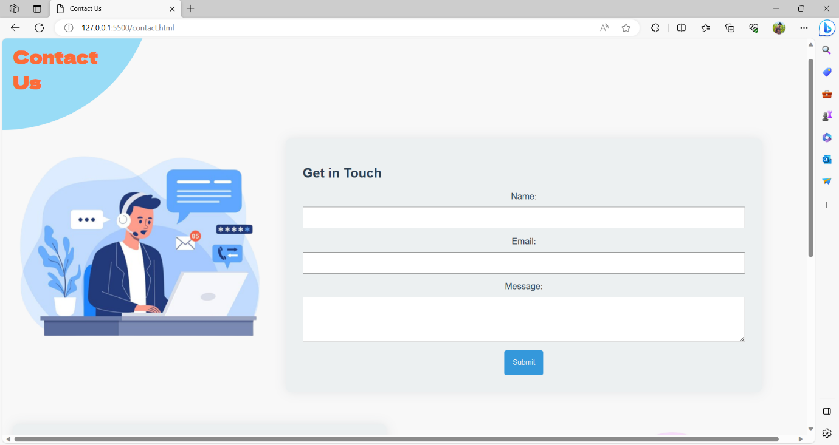

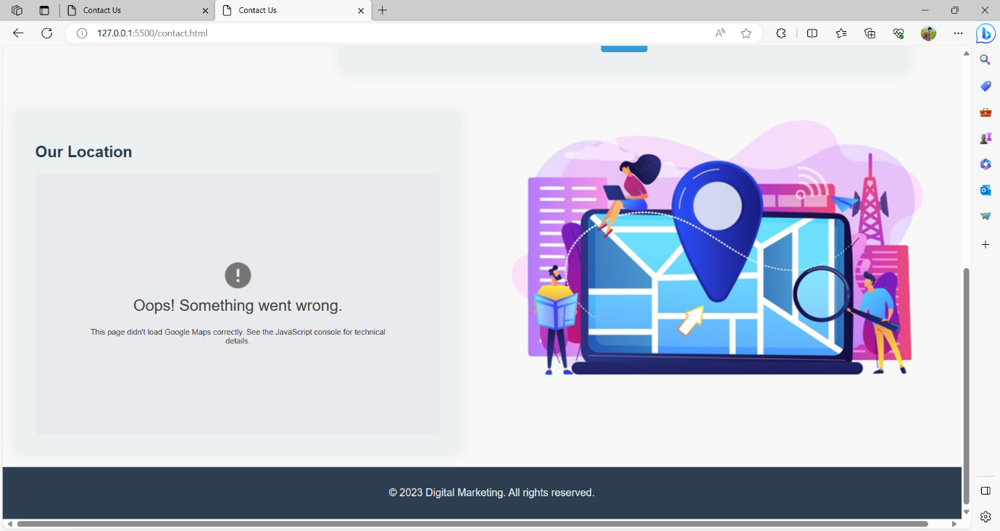

**OUTPUT:**





















